Airfoil Selection

This study conducted a comparative evaluation of five airfoils (E423, NACA 4415, S1223, SD7062, FX 63‑137) for UAV wing applications using three principal criteria: aerodynamic performance, manufacturability, and structural stability. Aerodynamic behaviour was first quantified using seven weighted parameters (Cd_min, Cmo, stall angle, Cl/Cdmax, Cl at alpha =0, Clmax , and stall slope), yielding an aggregate aerodynamic score for each airfoil, with FX 63‑137 establishing the benchmark.​​
For manufacturability, three sub‑criteria were defined: thickness‑to‑chord ratio (greater thickness preferred for internal volume), trailing‑edge thickness (thicker edges favoured for robustness and ease of machining), and camber complexity (lower camber preferred for simpler tooling and inspection). Corresponding non‑dimensional scores were assigned to each airfoil based on published geometric properties, and a composite manufacturability index was obtained by averaging the three sub‑scores, with NACA 4415 emerging as the most manufacturable section.​
Structural stability was characterised using maximum thickness, location of maximum thickness (with 25–35% chord treated as optimal for spar placement), and leading‑edge radius (larger radii providing improved torsional stiffness without excessive drag). After scoring these sub‑criteria on a common 0–1 basis and averaging, SD7062 was identified as the structurally most efficient airfoil owing to its favourable thickness distribution and large leading‑edge radius.​
All three composite indices (aerodynamic, manufacturability, structural) were then independently normalised to a 0–100 scale by dividing by the highest value in each category, ensuring that the best-performing airfoil in each criterion received a score of 100. A final performance metric was formulated as a weighted sum: 50% aerodynamic, 20% manufacturability, and 30% structural stability, reflecting the relative importance of cruise efficiency, producibility, and structural robustness for the intended UAV application.​
Although NACA 4415 achieved the highest overall score (≈95), primarily due to its combination of near‑optimal aerodynamic behaviour, excellent manufacturability (notably its practical trailing‑edge thickness), and robust structural characteristics, it was ultimately excluded from consideration because its available Clmax did not satisfy the high‑lift requirement defined for the UAV mission. With NACA 4415 removed on this performance constraint, SD7062 and FX 63‑137 became the leading candidates, SD7062 benefiting from superior structural stability and FX 63‑137 from marginally better aerodynamic performance, while E423 and S1223 continued to lag due to weaker manufacturability and structural metrics despite acceptable aerodynamics.

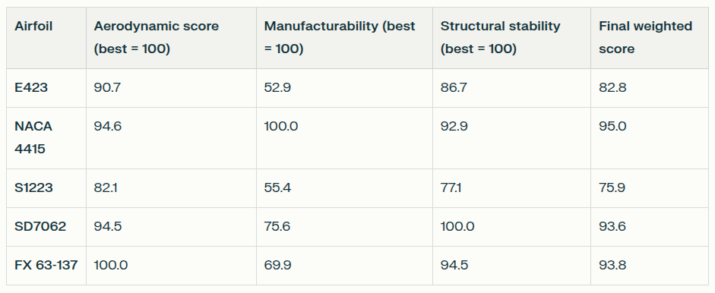
We then submitted this airfoil SD7062, for further analysis and optimisation by our wing team.

Images:
